**Asset Management System (AMS)**

**Introduction**

The **Asset Management System (AMS)** is a smart mobile and web-based application that helps companies keep track of their physical assets like laptops, printers, tools, etc.

It makes asset tracking:

* Faster ✅
* Easier ✅
* More Accurate ✅

Using **RFID technology** and **barcode scanning**, AMS ensures that no asset goes missing, and every asset is recorded properly.

**What Problems Does AMS Solve?**

1. **Manual tracking is slow** – AMS automates the process.
2. **Assets go missing often** – AMS helps locate misplaced items quickly.
3. **No proper records** – AMS keeps your data organized and secure.
4. **Hard to audit everything** – AMS simplifies auditing with a few taps/clicks.

**Key Features (Mobile + Web)**

**Mobile App (For on-site teams)**

* Scan assets using RFID or mobile camera.
* Show if the asset is **Found, Missing, or Misplaced**.
* Save audit data offline (without internet).
* Export final report to the backend with one click.

**Web Panel (For Admin)**

* Add/Edit assets and assign them to locations or categories.
* Generate barcodes for each asset.
* Monitor audit results in real-time.
* Export/Import asset data via Excel or API.

**How It Works (Simple Steps)**

1. **Add Assets & Locations** from the web panel.
2. **Import that data** into the mobile app.
3. **Start scanning** using RFID or a Camera.
4. The app will show:
   * ✅ Found
   * ⚠️ NotFound
   * 🆕 New Assets
5. **Export the result** to your system/server.

**Benefits to Your Organization**

* Save **time and money** by reducing manual work.
* Quickly know which assets are **missing** or **in the wrong place**.
* Make your **inventory audits easy and accurate**.
* Access your asset data anytime from the **web or mobile**.

**Technology Used (Just for Reference)**

| **Platform** | **Tech Used** |
| --- | --- |
| Mobile App | Flutter (Cross-platform) |
| Web Admin Panel | ASP.NET |
| Database | SQLite (local), API sync |
| Hardware | UHF RFID Scanner, Camera |

**Screenshots**

**WEB APP(AMS)**

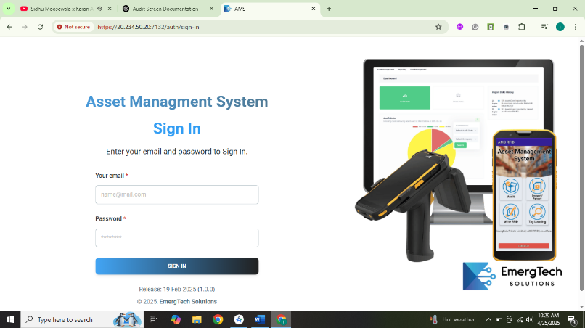

**Login:**

The Login Screen is the entry point of the web application, providing secure access to authorized users. This screen is designed with a clean and user-friendly interface, allowing users to log into the system using their registered credentials (such as username/email and password).

It plays a critical role in authentication and security, ensuring that only verified users can access the internal features of the web application. Once the user enters valid credentials, they are redirected to the dashboard or relevant landing page based on their role.

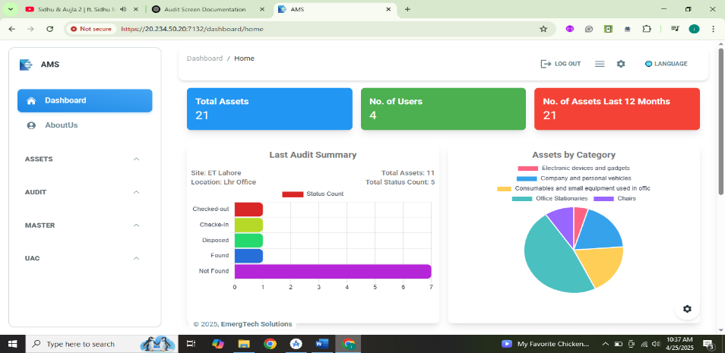

**Dashboard:**

The **Dashboard Screen** serves as the central hub of the AMS (Asset Management System) web application. It provides a comprehensive and visual summary of the key metrics related to asset tracking and audit activities across different sites and locations. This screen is designed for both **administrative** and **auditing roles**, enabling them to monitor the system at a glance.

**Key Features:**

| **Feature** | **Description** |
| --- | --- |
| **Total Assets** | Displays the total number of assets currently stored in the system. |
| **Number of Users** | Indicates how many users are registered and using the system. |
| **Assets Last 12 Months** | Shows how many assets have been recorded or updated in the past year. |
| **Last Audit Summary (Bar Graph)** | Visualizes the latest audit result by status (e.g., Found, Not Found, Checked-Out, Disposed). |
| **Assets by Category (Pie Chart)** | Displays the distribution of assets grouped by their categories, such as Office Stationery, Chairs, etc. |
| **Sidebar Navigation** | Allows users to access different modules like Assets, Audit, Master, and UAC. |
| **Language Switcher** | Let the user change the application's language (if multilingual support). |
| **Logout Option** | Securely logs the user out of the system. |

**Location & Site Summary Table (Located below charts):**

This table shows a **breakdown of assets per location and site**, helping users quickly identify how many assets exist at each physical location. This is especially useful for:

* Asset distribution planning
* Site-based reporting
* Audit preparation

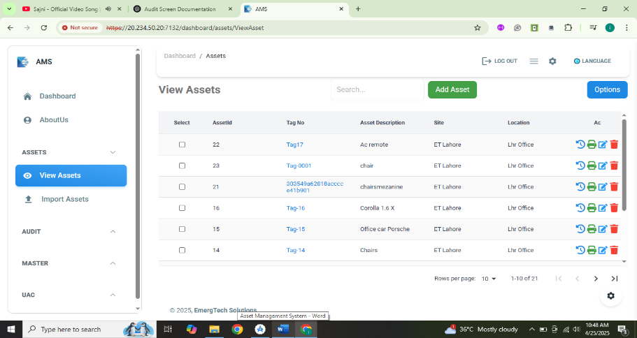

**View Asset:**

The **View Asset screen** is a dynamic interface where all system-registered assets are listed. This screen allows the user to **view, manage, update, and organize assets** effectively. It provides comprehensive tools to perform asset-related operations such as editing, deleting, and generating barcodes/QR codes for printing.

This screen is essential for administrators, asset managers, and audit personnel to keep the inventory accurate and up to date.

**Key Features:**

| **Feature** | **Description** |
| --- | --- |
| **Asset Listing Table** | Displays all assets in a tabular format with searchable and sortable columns (e.g., Asset Name, Location, Category, Status). |
| **Edit Asset** | Allows modification of asset details such as name, location, category, or condition. |
| **Delete Asset** | Provides the option to remove an asset from the system permanently. Includes a confirmation prompt to avoid accidental deletions. |
| **Print Functionality** | Enables printing of individual or selected asset records with complete details. |
| **Barcode / QR Code Generator** | Select one or multiple assets to generate and print their barcode or QR code labels for physical tagging. |
| **Bulk Selection** | Easily select multiple assets using checkboxes for batch actions like printing. |
| **Search & Filter** | Search bar and category/location filters allow quick navigation through the asset list. |

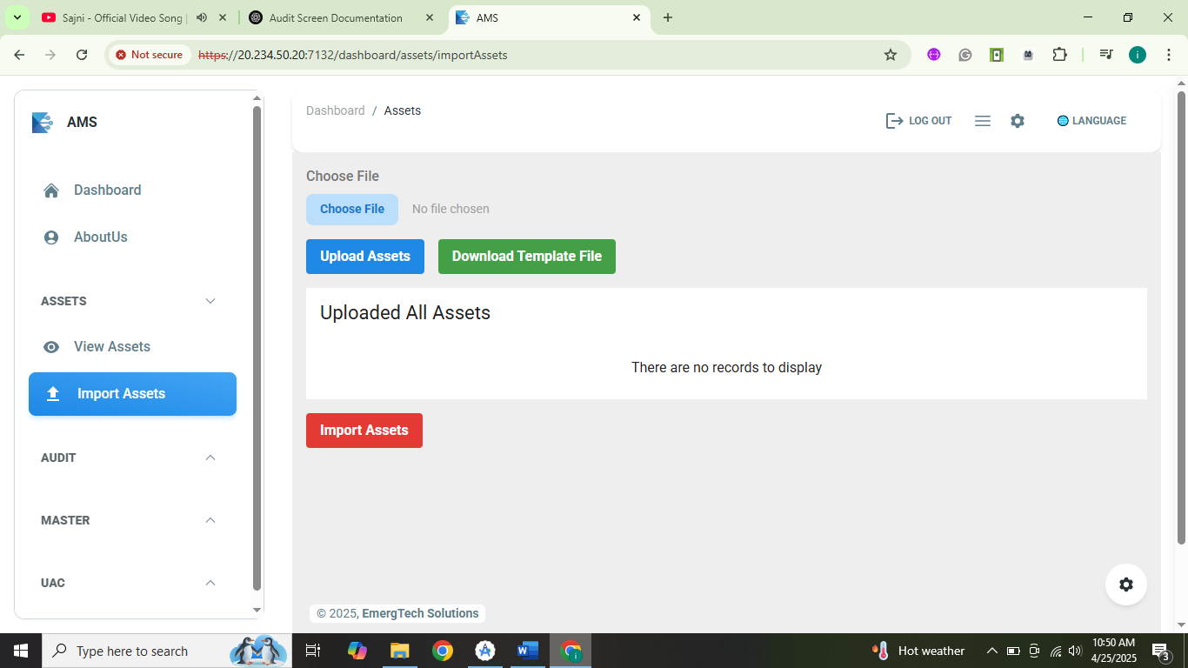

**Import Asset:**

The **Import Asset screen** provides users with the functionality to **bulk import asset records** into the system using a predefined **Excel template**. This screen significantly improves efficiency by allowing administrators to prepare asset data offline and upload it to the system in a structured manner. It is designed to handle **large-scale data import** seamlessly while ensuring data accuracy and consistency.

**Core Functionalities:**

| **Feature** | **Description** |
| --- | --- |
| **Download Excel Template** | Allows users to download a preformatted Excel template that contains necessary columns (like Asset Name, Category, Location, etc.) to ensure proper data structure before uploading. |
| **Choose File** | Users can select their filled Excel sheet containing asset details using the file picker. |
| **Import Button** | After selecting a file, the "Import" button is used to upload and save the asset data into the system. |
| **Location Selection Dropdown** | Enables users to specify the **target site and location** where the uploaded assets should be stored. |
| **Validation Check** | Ensures that the data structure matches the template before import. Alerts user if formatting is incorrect or fields are missing. |
| **Success/Failure Feedback** | After importing, a confirmation message is displayed showing how many assets were successfully added or if any errors occurred. |

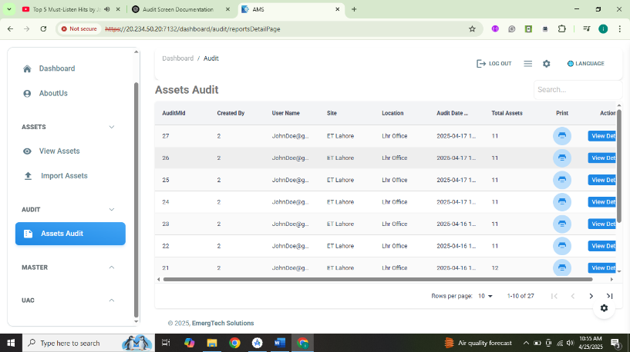

**Assets Audit:**

The **Audit screen** is a vital module of the Asset Management System (AMS) web application. It serves as a centralized interface where all asset audit records exported from the **mobile application** are displayed and managed. This screen is designed to assist **administrators**, **auditors**, and **asset managers** in tracking the results of on-site audits performed using the mobile app.

It ensures that **field audits are synchronized with the web platform**, allowing users to **review, print, verify, and analyze** audit logs in one place.

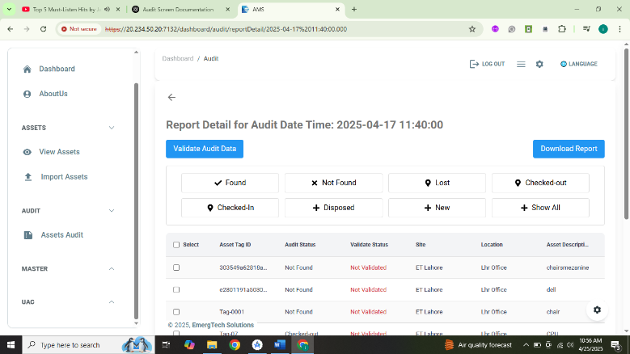

**Audit Details:**

The **View Audit** screen serves as the focal point for users to review and analyze the audit data exported from a mobile device. It is designed for asset managers, auditors, and other stakeholders to ensure that the audit information is accurate before it is finalized and recorded in the system. The screen allows users to validate, modify, and export audit details, making it a crucial interface in asset management.

This screen provides the functionality to filter, validate, and export asset data associated with a particular audit session, ensuring that only accurate and reviewed data becomes part of the official asset records.

| **Feature** | **Description** |
| --- | --- |
| **Asset Status Filter** | Users can filter the assets by their current audit status. The available options include Found, Not Found, Lost, Checked-out, Disposed, Checked-in, New, and All. This functionality allows users to focus on specific categories of assets based on their status during the audit. |
| **Validate Audit Data** | Clicking the **"Validate Audit Data"** button allows users to confirm the status of assets. Before validation, the audit data remains in a temporary, editable state. Once validated, the data becomes locked, preventing further modifications to ensure accuracy and integrity. |
| **Download Report** | Users can export the entire audit report in a downloadable format (e.g., PDF, Excel) for offline viewing, submission, or backup. This is particularly useful for record-keeping and external audits. |
| **Asset Table** | The asset table presents a detailed list of all audited assets, including key fields like:  • **Asset Tag ID**: The unique identifier for each asset. • **Audit Status**: The status of the asset during the audit (e.g., Found, Not Found). • **Validation Status**: Indicates whether the asset data has been validated or is still in draft form. • **Site**: The site where the asset is located. • **Location**: The specific area or room where the asset is situated. • **Asset Description**: A brief description of the asset (e.g., Laptop, Projector). |
| **Selection** | Users can select one or multiple assets using checkboxes to perform actions such as validation or exporting. This feature is key for bulk actions and helps users focus on specific assets for further review. |
| **Validation Control** | Before an asset is validated, any changes made (e.g., updating its audit status) will not be saved to the system. Validation ensures that only finalized audit data is pushed to the core system, avoiding accidental data loss or corruption. |

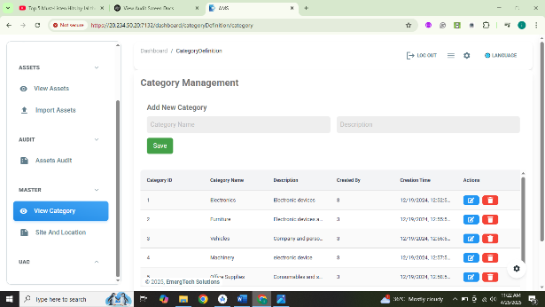 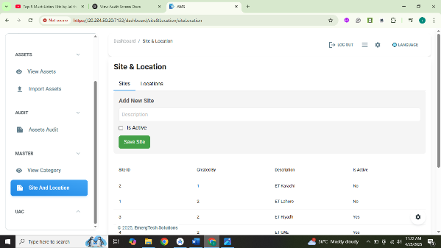

**Master Screen:**

The **Master Screen** serves as the administrative hub for managing key asset management data elements within the system. It allows users to create, edit, and delete assets' locations, sites, and categories. This screen is essential for maintaining the structure and organization of the asset tracking system, giving administrators full control over asset assignment.

The Master Screen simplifies the process of defining organizational elements (like sites and categories) and ensures that the asset database is well-organized. Users can perform actions such as adding new sites, creating locations within those sites, and assigning categories to assets. All these elements are crucial in tracking and managing assets effectively.

**UAC Module:**

The **User Access Control (UAC) Module** enables administrators to manage system users, their roles, and associated permissions. It plays a critical role in ensuring that only authorized personnel can access certain parts of the application. The module allows for the creation of users, assignment of roles, configuration of role-based permissions, and modification of user credentials (such as changing passwords).

This module is vital for maintaining the security of the application, ensuring that different users have appropriate access to system features based on their roles.

| **Feature** | **Description** |
| --- | --- |
| **Create User** | Admins can create new users, assign them specific roles, and set other attributes like email, password, and status (active/inactive). Creating users helps in managing who has access to the system. |
| **Create User Role** | Admins can define new user roles. Roles specify the access level of users (e.g., Admin, Manager, User). Each role can have different permissions associated with it. |
| **Assign User Role** | Admins can assign one or more roles to a user. A user can have multiple roles depending on their responsibilities. |
| **User Role Permissions** | Admins can configure specific permissions for each role. Permissions control which actions (e.g., View, Edit, Delete) the user can perform on certain entities within the system. |
| **Change Password** | Users can change their own password or an admin can reset a user’s password. This feature ensures that users maintain secure and updated credentials. |
| **Search Users** | Users can be searched by name, email, role, or status to quickly locate and manage them. |
| **User List** | Displays a list of all users in the system along with key information like name, role, and status. |
| **Role Configuration** | Admins can configure roles by defining their access privileges. This includes allowing or denying access to certain screens, actions, and data based on the role. |
| **Permission Management** | Admins can configure permissions at a granular level for each role, specifying whether they can view, edit, or delete data within certain modules. |

**Create User Role:**

* Admins can define user roles based on the organizational hierarchy or required access levels. For example, roles could be **Admin**, **Manager**, **Employee**, etc.
* Each role comes with predefined access rights, which can be modified later.

**Assign User Role:**

* A user can be assigned one or more roles.
* Roles determine the level of access a user has within the system.
* A user with the **Admin** role may have full access, while a user with the **Manager** role may have restricted access to only specific modules.

**User Role Permissions:**

* **Permissions** define what a user can or cannot do within the system. Permissions are set at the role level and can include:
* **View**: Ability to view data.
* **Edit**: Ability to modify data.
* **Delete**: Ability to delete data.
* **Create**: Ability to add new records.
* Permissions are configured for each role, ensuring users only have access to necessary data and features.

**Change Password:**

* Users can reset their password via the "Change Password" feature, either by themselves or through an admin.
* If a user forgets their password, the admin can reset it or send a password reset link.
* Strong password policies should be applied (e.g., minimum length, mix of characters) to ensure security.

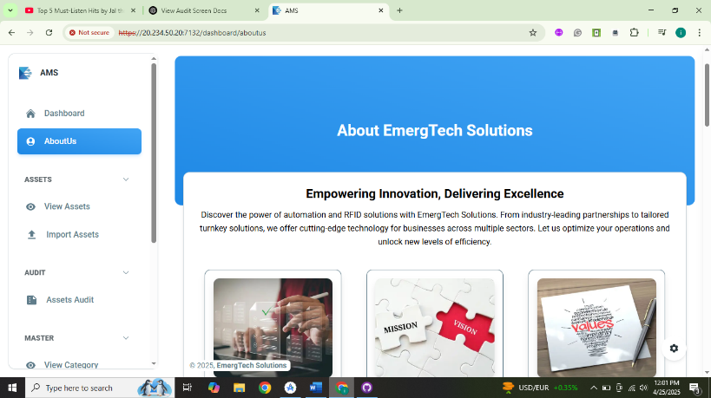

**About Us:**

* The **About Us** screen provides users with detailed information about the **Asset Management System (AMS)** and the company behind it. This screen is a vital source of information for both new and existing users, offering an overview of the system’s capabilities, features, and the company’s mission. It establishes transparency and builds trust by providing essential background on the AMS and the organization that developed it.
* The **About Us** screen is designed to deliver essential details in a user-friendly and concise format. It is an important touchpoint for users who want to know more about the product and its creators.

**MOBILE APP(AMS)**

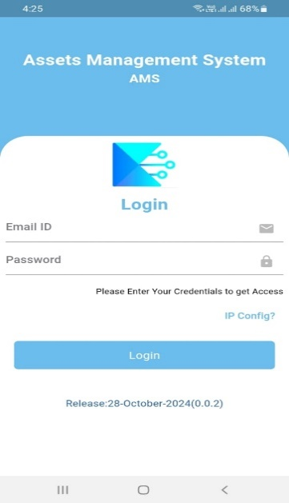

**Login Screen**

The **Login Screen** is the entry point of the AMS mobile application. It ensures that only authorized users can access the system.

**Features:**

* **Email & Password Authentication:**  
  Only registered users can log in to access the app.
* **IP Configuration Option:**  
  You can set or change the IP address of your server using the **"IP Config"** link before logging in.
* **Release Information:**  
  Shows the current app version and release date (e.g., Release: 28-October-2024 (0.0.2)).

**Purpose:**

This screen provides a **secure login gateway** so that only valid team members can use the app to scan and track assets.

**User Flow:**

1. Enter **Email ID** and **Password**.
2. Tap **Login** to proceed to the Dashboard.
3. If required, update your **Server IP** using "IP Config?".

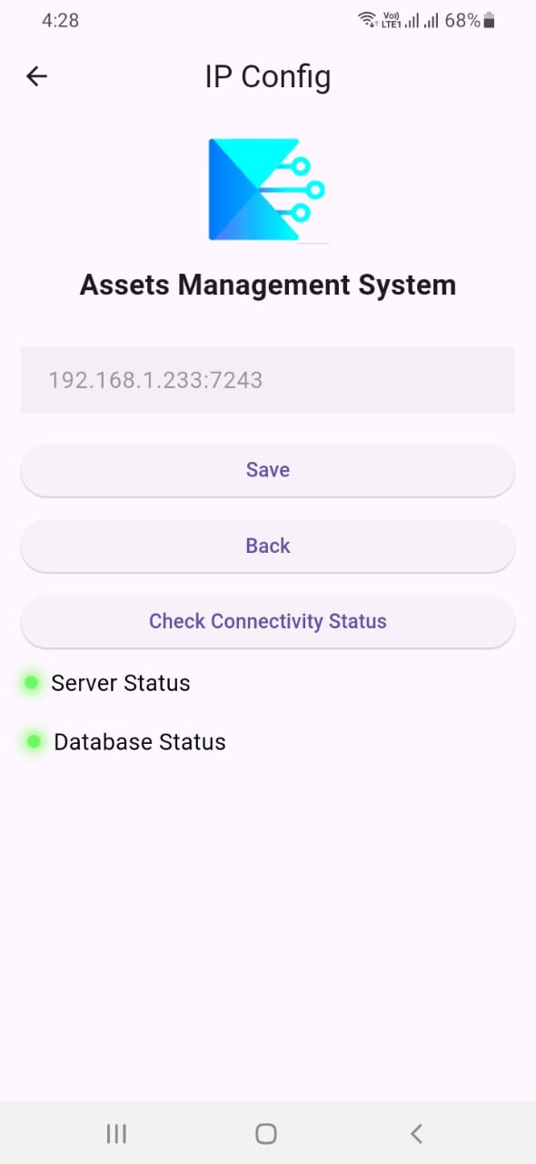

**IP Configuration – Server Connection Setup**

The **IP Config Screen** allows users to configure the backend server connection for the AMS (Assets Management System) application.

**Key Features:**

* **IP Address Input:**  
  Users can enter or update the server IP address and port (e.g., 192.168.1.233:7243).
* **Save Configuration:**  
  Saves the IP settings for backend connectivity.
* **Check Connectivity Status:**  
  Verifies connection with:
  + ✅ **Server Status**
  + ✅ **Database Status**
* **Back Button:**  
  Returns to the login screen without saving changes.

**Purpose:**

This screen enables the app to connect to the correct server and database, ensuring that users are accessing the most up-to-date asset data in real-time.

**User Flow:**

1. Enter the **server IP address** and **port**.
2. Tap **Save** to apply changes.
3. Use **Check Connectivity Status** to verify server and DB connection.
4. Green indicators mean successful connection.

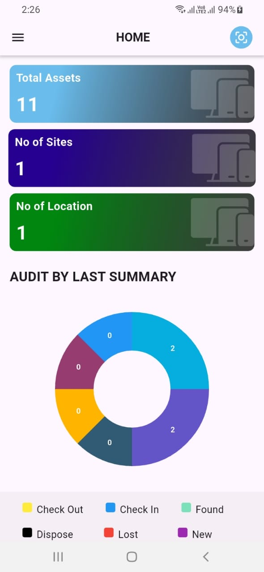

**Dashboard**

The **Dashboard Screen** is the main overview panel of the **Assets Management System (AMS)**. It provides a quick summary of total assets, site and location information, and the status of assets based on the latest audit.

* **Total Assets:**  
  Shows the total number of assets currently registered in the system.  
  ➤ *Example:* 11
* **Number of Sites:**  
  Represents the total number of sites where assets are deployed.  
  ➤ *Example:* 1
* **Number of Locations:**  
  Indicates the number of physical locations defined under the sites.  
  ➤ *Example:* 1

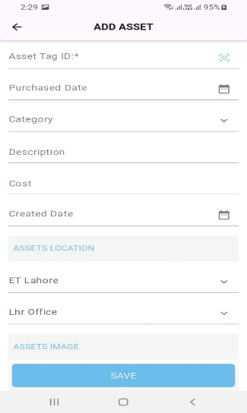

**Add Asset Screen**

The **Add Asset** screen is used to manually register a new asset in the system. It allows users to input essential information related to the asset including its identification, purchase details, location, and more.

* **SAVE**: Saves the asset information into the local database or sends it to the server, depending on app logic. Required fields must be filled before submission.

**Validation**

* **Asset Tag ID**: Mandatory
* Optional: Other fields may have validations depending on backend requirements (e.g., valid date format, cost as numeric only).

**Additional Features**

* Barcode/QR code scanning for Asset Tag ID.
* Dynamic dropdowns for **Category**, **Site**, and **Location** populated from backend/local DB.
* User-friendly **Date Pickers** for both dates.
* Clean UI design with field grouping (Location & Image).

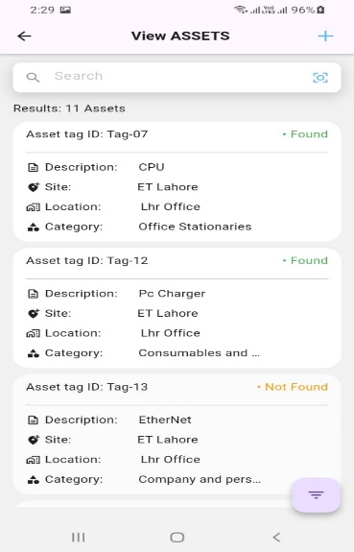

**View Assets Screen:**

The **View Assets** screen displays a list of all added or imported assets. It includes search, scanning, and filtering capabilities to quickly locate or manage assets. Each asset card shows its key attributes and whether it has been found or is missing.

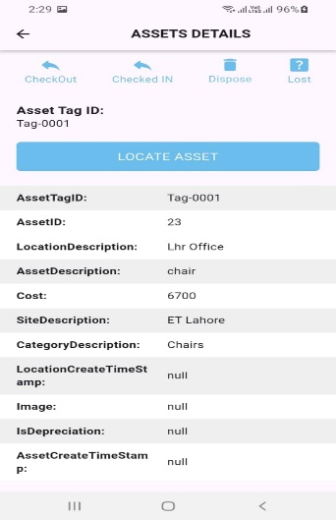

**Asset Details:**

This screen shows detailed information for a selected asset, including status updates, current location, and history management options like CheckOut, CheckIn, Dispose, and Lost.

**Locate Button:**

* **LOCATE ASSET**: This button is used to start tracking the asset using RFID or other methods.

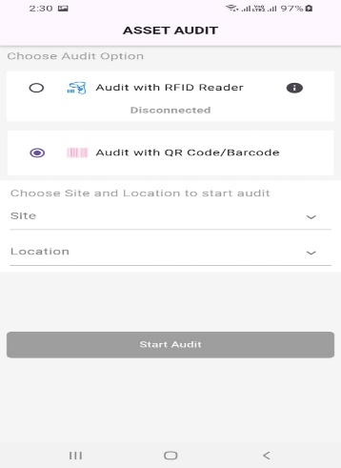

**Audit Screen Description:**

"This screen allows you to perform asset audits using either Barcode or RFID. Select your preferred method to scan and verify assets against the database. Based on the scan results, assets will be marked as Found, Misplaced, or Missing to help maintain accurate inventory records."

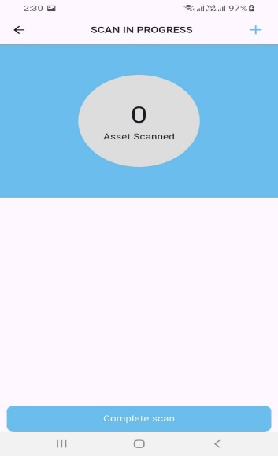

**RFID Scanning Screen**

The **RFID Scanning Screen** allows users to scan RFID tags using an external RFID reader. Upon triggering the scan action, the reader captures all nearby RFID tags and displays them in a structured list format on the screen. This screen is typically used for auditing, tracking, or locating tagged assets in the field. The scanning process is fast and supports batch scanning of multiple tags in real-time.

* Initiates RFID scanning when the user presses the scan trigger.
* Retrieves all nearby RFID tag IDs within range.
* Displays scanned tags in a live-updating list.
* Ensures seamless integration with RFID hardware.
* Provides user-friendly interface for reviewing scanned data.

**Usage:** This screen is primarily used during physical audits or asset tracking tasks, where users need to verify the presence of tagged assets within a specific area.

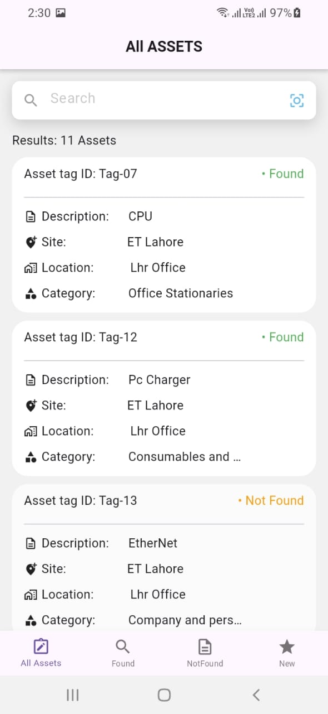

**All Assets**:

The **Audit Screen** in the AMS (Asset Management System) app serves as the central interface for performing asset audits using either RFID tags or barcode scanning. It is designed to allow users to easily verify the presence and status of each asset within a selected location or site. The screen displays all assets fetched from the local database and provides live feedback as assets are scanned, making the audit process faster, more accurate, and efficient.

This screen plays a key role in helping organizations keep track of their physical inventory by verifying if an asset is currently **present at the expected location**, **missing**, or **newly discovered** during the audit. Based on the scanned input, each asset is classified into one of three categories:

**Found:**

* These are assets that **exist in the local database**, and their **tag or barcode has been successfully scanned** during the audit process.
* The system verifies that both the asset's tag and its location match the database record.
* Assets marked as *Found* are displayed with a green status indicator (• Found), confirming their availability.

**Not Found:**

* These assets are **listed in the local database** but were **not scanned or detected** during the audit session.
* This may indicate that the asset is **missing**, misplaced, or was not present at the time of the audit.
* They are labeled with an orange status indicator (• Not Found).

**New:**

* These assets are **not available in the database** but are detected during the audit via manual entry, barcode, or RFID scan.
* This usually indicates a **new asset that has not been registered** in the system previously.
* Such assets are shown in the **New** tab for review and future action.

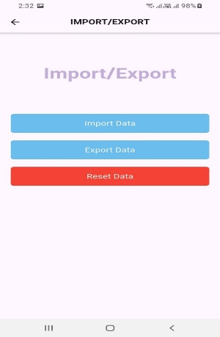

**Import Screen**

The **Import Screen** provides key data synchronization functionality between the application and the server. It includes three main buttons — **Import**, **Export**, and **Reset Data** — each handling specific data operations related to site and asset management.

**Buttons and Their Functionality:**

1. **Import**
   * Fetches **site** and **location** data from a remote API.
   * Saves the retrieved data into the local SQLite database.
   * Ensures the application has the latest reference data for asset tracking and auditing.
2. **Export**
   * Gathers all asset data stored in the local database.
   * Sends the compiled data to the server via an API call.
   * Typically used after auditing or tracking tasks to synchronize results with the backend.
3. **Reset Data**
   * Deletes all existing data from the local database.
   * Used to clear old or irrelevant data before starting a new import cycle or audit session.

**Usage:** This screen is crucial for maintaining data accuracy and synchronization between the app and the server. It ensures that field operations are conducted using up-to-date location/site information and that results are efficiently reported back to the central system.

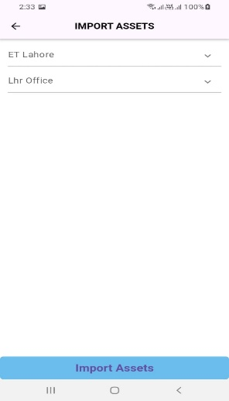

**Import Asset**

The **Export Asset Screen** is used to initiate the asset data import process based on a selected **Site** and **Location**. This screen helps users define the context (site and location) in which an audit will be performed, and ensures that only the relevant assets are imported into the system for auditing.

* **Site Selection**:  
  Allows users to select the desired site from a dropdown or list. This site represents the physical or organizational location where assets are assigned.
* **Location Selection**:  
  Based on the selected site, the user can further narrow down the scope by selecting a specific location within that site.
* **Import Assets Button**:  
  Once the site and location are selected, tapping this button triggers an API call to fetch the asset data associated with the chosen site and location.  
  The imported data is stored locally in the database for use during the audit process.

**Usage Flow:**

1. User selects the **Site**.
2. User selects the **Location** associated with the selected site.
3. User taps **Import Assets** to download relevant asset data.
4. Assets are saved locally and can now be audited using RFID scanning or manual verification.

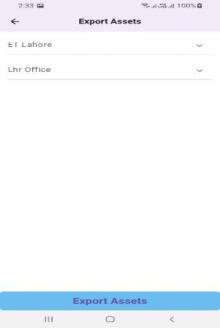

**Export Assets**

The **Export Screen** is used to export audited asset data for a specific **Site** and **Location** back to the server. This screen ensures that only the relevant and updated data — based on the previously selected site and location during the import process — is uploaded, maintaining data accuracy and relevance.

* **Displays Selected Site & Location**:  
  Automatically shows the site and location that were used during the asset import and audit process.
* **Export Audited Data**:  
  On tapping the **Export** button, the application gathers all audited asset data for the selected site and location from the local database and sends it to the server through an API call.
* **Data Integrity**:  
  Ensures that only completed and validated audit data is exported, avoiding duplication or incorrect uploads.

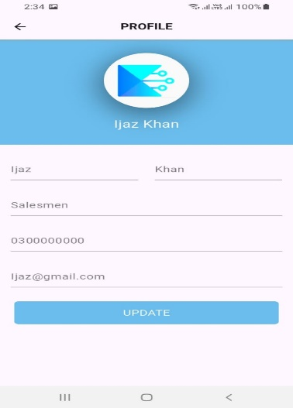

**Profile**

The Profile Screen displays the user's basic information such as name, email, and role. It allows the user to view and manage their account-related details within the app.

* Shows user details like name, email, and assigned role.
* Provides a clean and simple layout for quick reference.
* May include options like Logout, Change Password, or Edit Profile (if implemented).

**Usage**: This screen helps users verify their login status and manage personal information while using the app.

**Usage Flow:**

1. The user completes an audit for a specific site and location.
2. On the Export Screen, the system shows the previously used site and location.
3. User taps **Export** to upload audited results to the server.
4. A confirmation or success message is displayed upon successful export.

**What You Get**

* Full access to a **mobile app** for scanning and audit.
* A **web panel** for asset and location management.
* **Support and customization** based on your organization’s needs